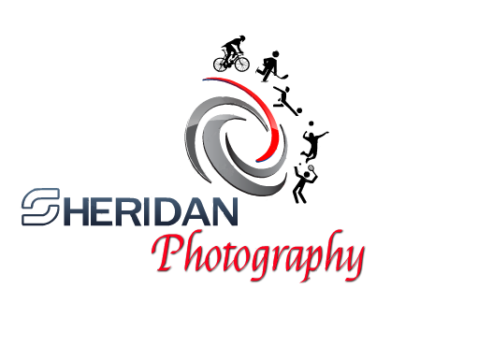

Photo Release Form

Job reference______________________________
Name____________________________________

Location__________________________________
Date _____________________________________

I permit the members of Sheridan Photography the use of my photos to be used as promotional material including Website design and other advertising systems. I accept this picture to be printed, projected, and included in the website or other media marketing. I also content the use of names or other specific material to be used for promotional, publicity or other organizational purposes of the photos.

I have read this release form before signing below and understand the contents, meaning and impacts of this release. I agree to be fully responsible for my own participation and hold Sheridan Photography not responsible from the use of photographs.

This consent applies to all of the photos taken between____________ and ___________

Authorized Signature Date

Address

City State Zip

